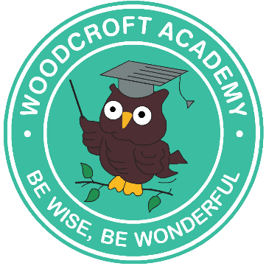

**I have been supported by an adult.**

**I have exceeded the learning objective today.**

⭐️

👤

**I have met the learning objective today.**

**Today, I was the star learner.**

👣

👍z

👏

**I have worked hard and I am working towards meeting the lesson objective.**

I

👍👍

**Pupil Feedback**