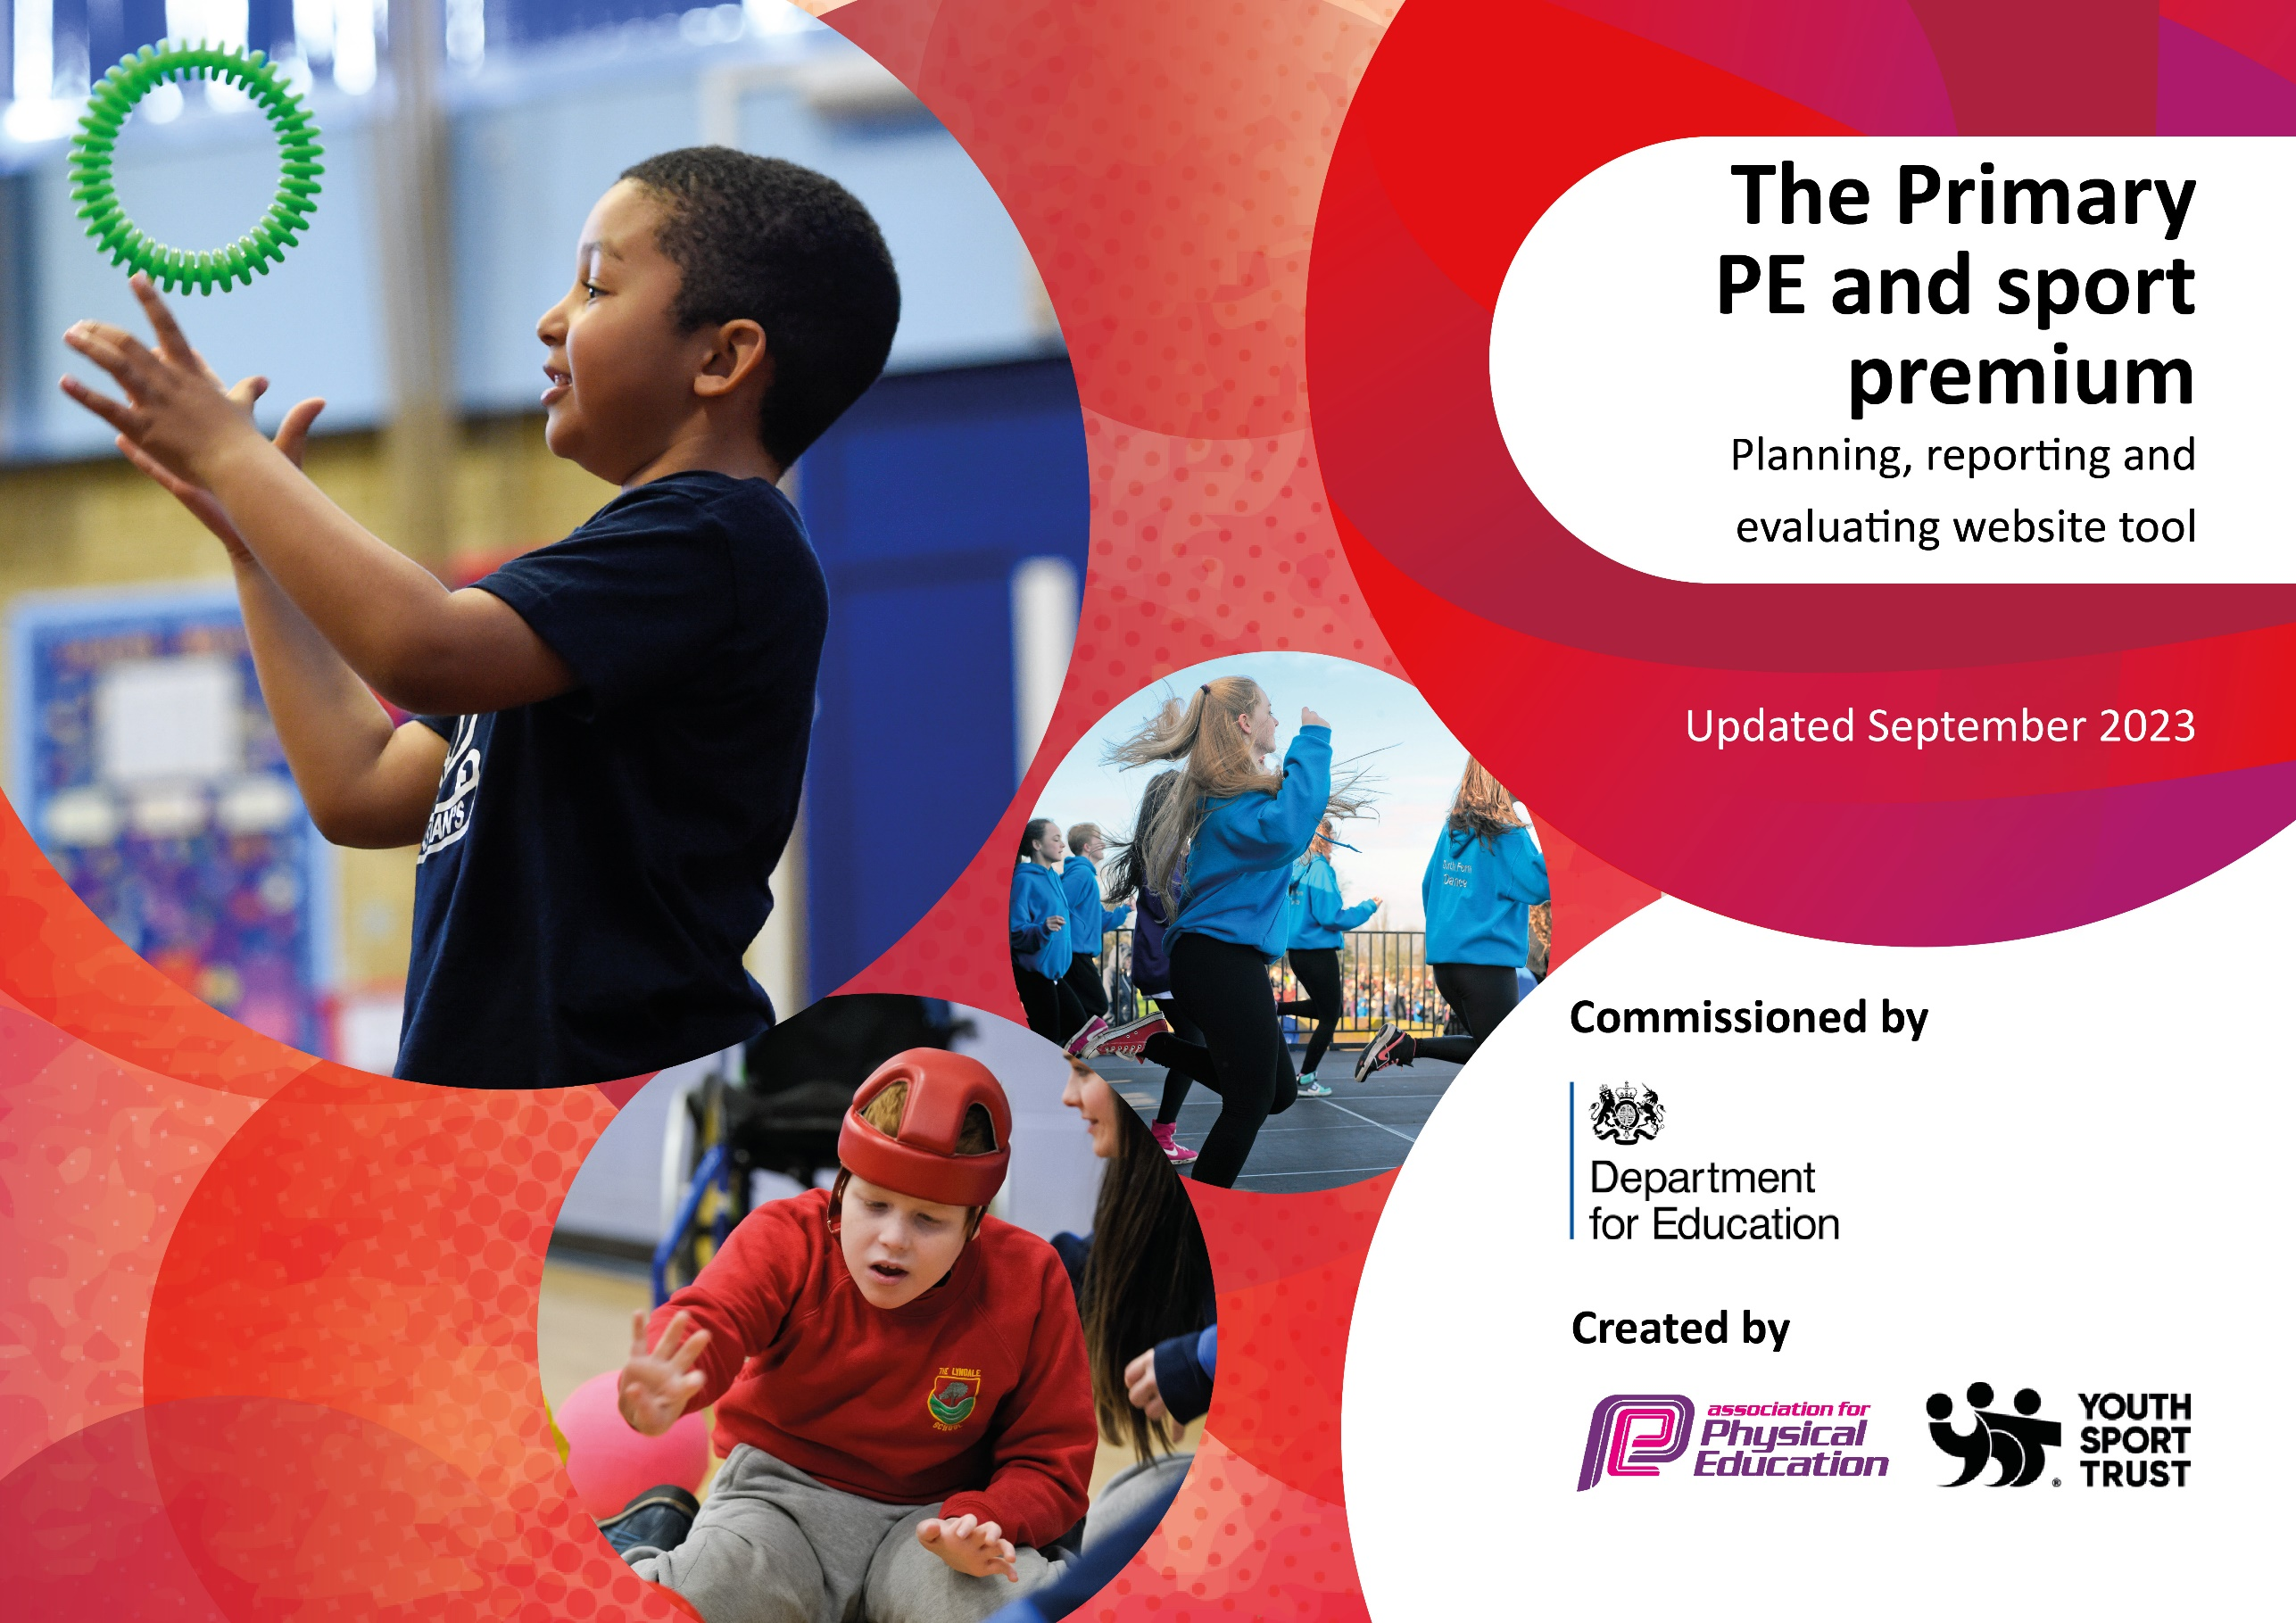

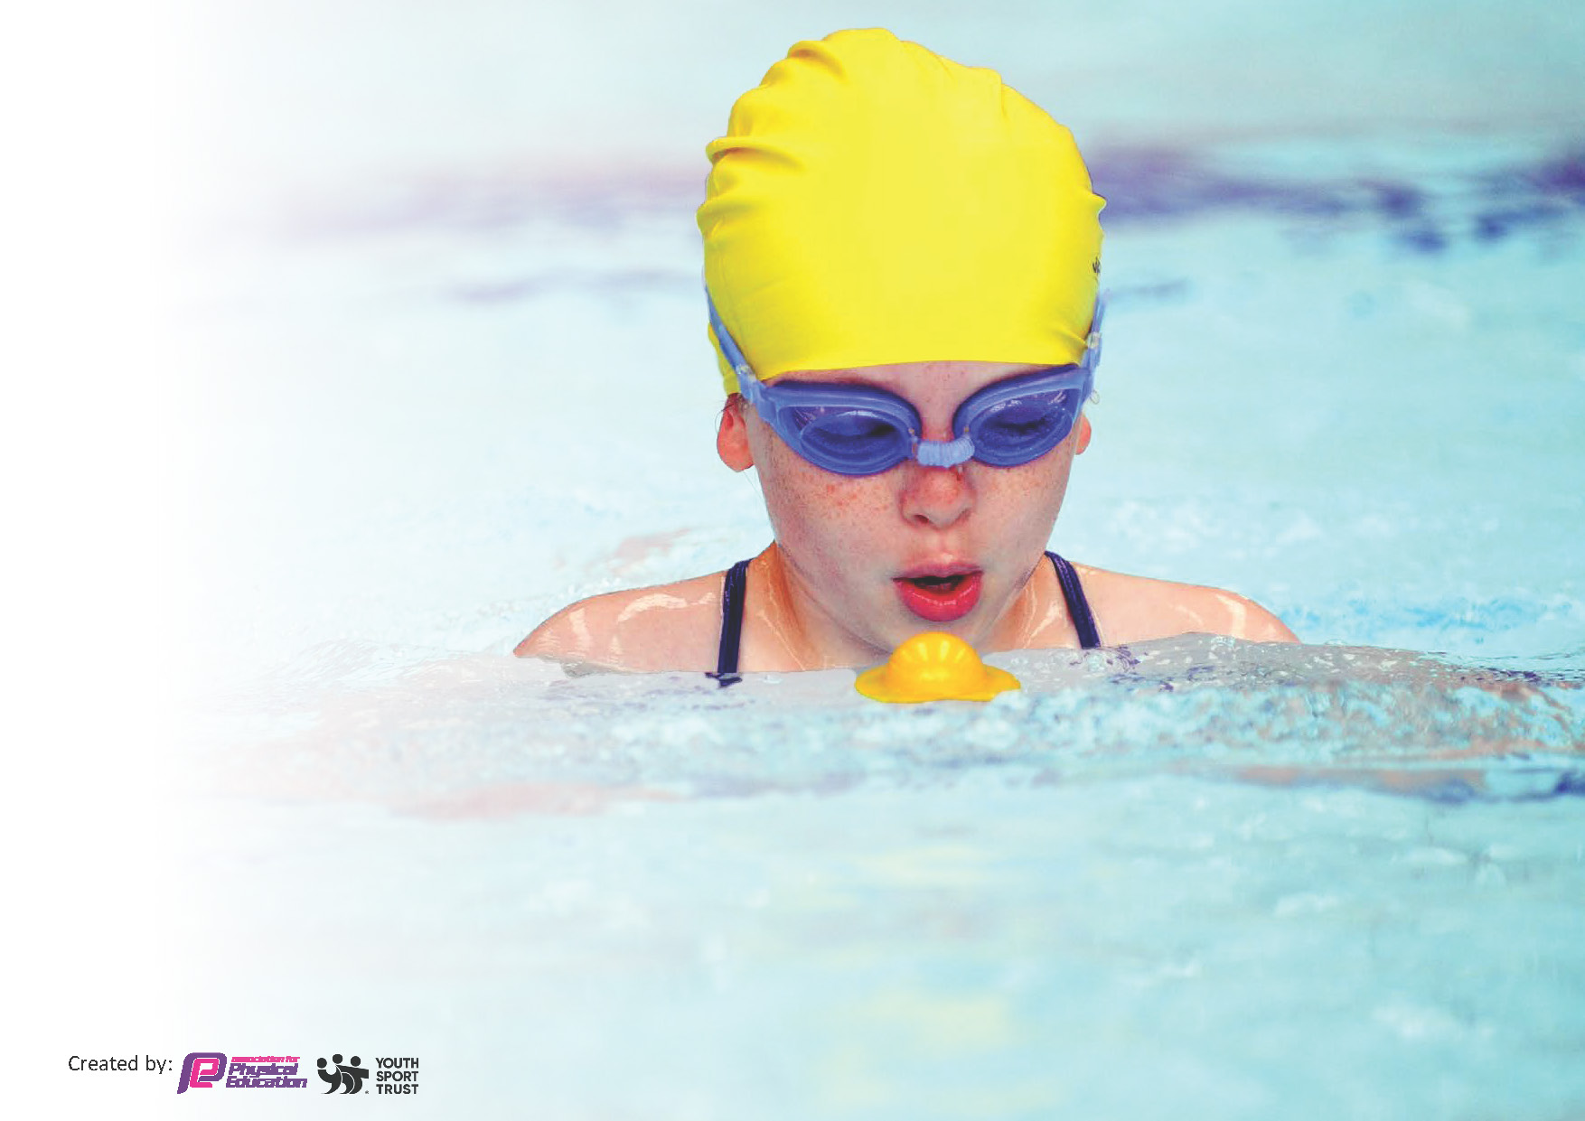
This template can be used for multiple purposes:
by:
- It enables schools to effectively plan their use of the Primary PE and sport premium
- It helps schools to meet the requirements (as set out in guidance) to publish information on their Primary PE and sport premium
- It will be an effective document to support Ofsted inspections enabling schools to evidence progress in Physical Education (PE) and evidence swimming attainment, which forms part of the PE National Curriculum. We would recommend schools consider
the Intent, Implementation and Impact of any spend, as examined within the Education Inspection Framework.

It is important that your grant is used effectively and based on school need.

Schools must use the funding to make additional and sustainable
improvements to the quality of the PE, School Sport and Physical Activity (PESSPA)
they offer. This means that you should use the Primary PE and sport premium to:

- Build capacity and capability within the school to ensure that improvements made now will benefit pupils joining the school in future years
- Develop or add to the PESSPA activities that your school already offers.

The Primary PE and sport premium should not be used to fund capital spend projects; the school’s core budget should fund these. Further detail on capital expenditure can be found in the updated Primary PE and sport premium guidance.

The Primary PE and sport premium guidance, outlines 5 key priorities that funding should be used towards. It is not

necessary that spending has to meet all the key priorities, you should select the priorities that you aim to use any funding towards.

Although completing this template is not a requirement for schools, schools are required to publish details of how they spend this funding. Schools must also outline what the impact this funding has had on pupils’ PE and sport participation and attainment and how any spending will be sustainable in the future. All funding must be spent by 31st July 2024.

The Department for Education has worked closely with the Association for Physical Education (afPE) and the Youth Sport Trust (YST) to develop this template and encourages schools to use it. This template is an effective way of meeting the reporting requirements of the Primary PE and sport premium.
Review of last year’s spend and key achievements (2022/2023)

We recommend you start by reflecting on the impact of current provision and reviewing your previous spend.

Activity/Action | Impact | Comments
Access to high quality teaching resources to enhance the quality of teaching throughout the school. Access to increased range of high-quality resources to facilitate active play.  Training of Lunchtime staff and Sports leaders to facilitate active play. Funding for sports coach to deliver lunchtime club at least once per week.  Staff training on Primary PE Passport implementation.  Improved access to resources for staff to lead active play for improved behavior at playtimes.  FSM and SEND children planned for in both PE lessons and afterschool clubs.  High quality delivery of PE lessons throughout the school. Staff training to facilitate the delivery of active play. | Initial spend has ensured that all planned PE lessons are fully resourced. PE coordinator to complete a full PE order based on the long-term plan of the schools PE curriculum.  Observations show an increased participation in health and fitness. Improvement in lunchtime behavior and participation in games during lunchtimes. Increased participation of all children with the school in relation to physical activity.  Increased knowledge of Delivering PE curriculum through PE Passport.  Children are more active at playtimes and as a result behavior of pupils has improved.  Behavior tracking show less incidents of poor behaviors. Pupil voice shows positive views on active play.  All SEND children enabled to access all area of the curriculum with appropriate resources.  Observation have shown an improvement in the delivery and competence of teaching the PE curriculum. Children are improving their knowledge and participation in physical activity. After school club intake has been good. Further equipment needed to enhance the range of extracurricular clubs provided.

Key priorities and Planning
This planning template will allow schools to accurately plan their spending.

Action – what are you planning to do | Who does this action impact? | Key indicator to meet | Impacts and how sustainability will be achieved? | Cost linked to the action
Introduction of the daily mile during lunchtimes which will be 3 times per week.  Introduction of play leaders during lunch times.  Access of high-quality teaching resources to enhance the quality of teaching throughout the school.  Access to increase range of high-quality recourses to facilitate active play.  Staff training to support implementation of new scheme ‘Get Set for PE’.  Pupils to attend external competitions across a range of sports.  Continue to work with Staffordshire Active Travel to encourage active travel to and from school | Lunchtime supervisors and teaching staff will lead this activity – pupils from year 1 to 4 will take part.  Lunchtime supervisors will support play leaders to lead games with pupils from Nursery to year 2. Teaching staff will train play leaders to lead sessions. Pupils from all years will either lead or take part in planned games.  Purchase of additional PE resources to supplement PE lessons so all sports and activities in PE are fully resourced. All pupils to have access to equipment in order to achieve full potential in all areas of PE.  Purchase of additional play time resources and replenish any resources the need to be replaced and training for lunchtime supervisors.  Staff to have training on how to implement new scheme effectively. PE lead to monitor standards of PE across school  Pupils to attend external competitions against other schools across many sports.  Promote and participate with active travel campaigns and continue to engage with the School Travel Advisor to update and add to the audit. Bronze level achieved and working towards the Silver level accreditation. Purchase of Scooter Rack. | Indicator 2 – engagement of all pupils in regular exercise.  Indicator 2 – engagement of all pupils in regular exercise.  Indicator 1 – Increase confidence, knowledge and skills of all staff in teaching PE and sport.  Indicator 2 – engagement of all pupils in regular exercise.  Indicator 4 – A boarder experience of a range of sports and activities offered to all pupils.  Indicator 3 – The profile of PE and sport is raised across he school as a tool for school improvement.  Indicator 2 – engagement of all pupils in regular exercise.  Indicator 1 – Increase confidence, knowledge and skills of all staff in teaching PE and sport.  Indicator 1 – Increase confidence, knowledge and skills of all staff in teaching PE and sport.  Indicator 5 – participation in competitive sport.  Indicator 2 – engagement of all pupils in regular exercise. | More pupils within school will achieve their daily activity goal.  More pupils within school will achieve their daily activity goal.  More pupils in school will access high quality learning through well-resourced lessons.  More pupils will be more active during play times and lunch times.  Pupils will access high quality learning across many sports through access of training and new scheme Get Set for PE.  Pupil will compete in competitive sport against other schools.  Pupils will be encouraged to travel to school in different ways e.g. happy shoes day, scoot to school | £500  £2000  £2000  £1000  £7000  £1500  £3,020

Key achievements 2023-2024
This template will be completed at the end of the academic year and will showcase the key achievements schools have made with their Primary PE and sport premium spending.

Activity/Action | Impact | Comments

Swimming Data
Meeting National Curriculum requirements for swimming and water safety.
Priority should always be given to ensuring that pupils can perform safe self-rescue even if they do not fully meet the first two requirements of the National Curriculum programme of study

Question | Stats: | Further context  Relative to local challenges
What percentage of your current Year 6 cohort can swim competently, confidently and proficiently over a distance of at least 25 metres? | % | Use this text box to give further context behind the percentage.  e.g., 30% - we are struggling to get pool space due to our local pool closing so we have had to use a much smaller local school pool. We have had to limit the number of pupils attending swimming lessons during one term which means some pupils have attended fewer swimming lessons than others.
What percentage of your current Year 6 cohort can use a range of strokes effectively [for example, front crawl, backstroke, and breaststroke]? | % | Use this text box to give further context behind the percentage.  e.g., Even though your pupils may swim in another year please report on their attainment on leaving primary school at the end of the summer term 2024

What percentage of your current Year 6 cohort are able to perform safe self-rescue in different water-based situations? | % | Use this text box to give further context behind the percentage.
If your schools swimming data is below national expectation, you can choose to use the Primary PE and sport premium to provide additional top-up sessions for those pupils that did not meet National Curriculum  requirements after the completion of core lessons. Have you done this? | Yes/No
Have you provided CPD to improve the knowledge and confidence of staff to be able to teach swimming and water safety? | Yes/No

Signed off by:

Head Teacher: | Carly Wright
Subject Leader or the individual responsible for the Primary PE and sport premium: | Katie Moores, PE lead
Governor: | Lian Hyde
Date: | December 2023

