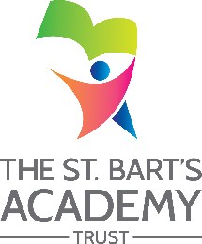

The St. Bart’s Academy Trust
Woodcroft Academy
Local Governing Committee Attendance Record

Current Attendees
 | Autumn Term  2021 | Spring Term  2022 | Summer Tern 2022
Governor Name | 16.11.2021 | 24.03.2022 | 29.06.2022
Eva Cerioni | P | P | P
Adam Geens | P | P | AA
Helen Hewitt | P | P | P
Julie Pettitt | P | P | P
Dave Suddaby | P | P | P
Lian Hyde | - | P | AA

KEY
P = Present
AB = Absent
AA = Absence Accepted
- = Not a current member

