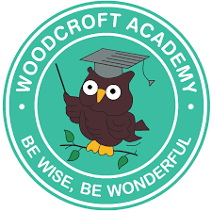
Woodcroft Academy Early Years Nursery Rhyme & Poetry Curriculum

Term | Nursery | Reception
Autumn 1 | Twinkle Twinkle  Baa Baa Black Sheep  Wind the Bobbin Up | Hey Diddle Diddle  Hickory Dickory Dock  Little Miss Muffet
Autumn 2 | When the Ants go Marching  Humpty Dumpty  Incy Wincey Spider | Old MacDonald  Jack and Jill Little  Bo Beep
Spring 1 | Wheels on the Bus  London’s Bridge | One, Two, Buckle My Shoe  Here We Go Round the Mulberry Bush
Spring 2 | Once I Caught a Fish Alive  5 Little Ducks  I’m a Little Teapot | Hot Cross Buns  5 Little Men in a flying Saucer  A Sailor Went To Sea
Summer 1 | The Grand Old Juke of York  Polly Put The Kettle On  If Your Happy and You Know It | The Fantastic Book of First Poems
Summer 2 | Mary, Mary Quite Contrary  Rock a Bye Baby  Row, Row, Row Your Boat | The Fantastic Book of First Poems

