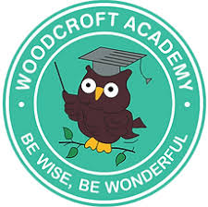
Woodcroft Academy – EYFS Curriculum Overview – 2025/26

Nursery

 | Autumn 1  Me, my family, my school  Autumn | Autumn 2  Celebrations  Winter | Spring 1  People who help us | Spring 2  Creatures great and small  Spring | Summer 1  Growing Plants | Summer 2  How to get places  Summer
Key text | ‘Elmer’ by David McKee  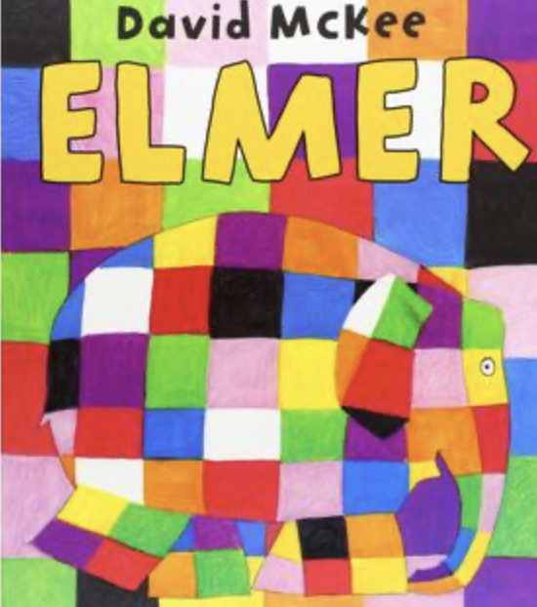 | ‘Stickman’ by Julia Donaldson  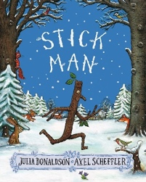 | 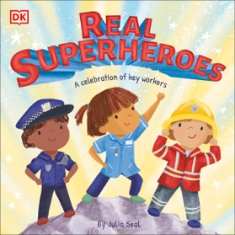  ‘ Real Life Superheroes’ by Julia Seal | ‘The Very Hungry Caterpillar’ by Eric Carle  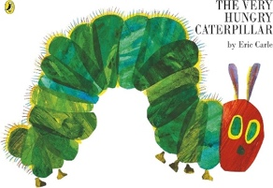 | ‘Jasper’s Beanstalk’ by Nick Butterworth and Mick Inkpen  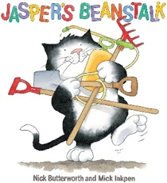 | ‘Naughty Bus’ by Jan Oke  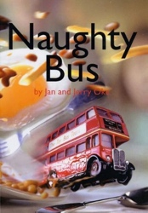
Supporting Texts | Autumn Poem – Shirley Hughes  Diwali (non-fiction)  After the Storm  Topsy and Tim first experience  Harry and the Dinosaurs go to School  Meg comes to school | Winter poem – Shirley Hughes  The Jolly Christmas postman  One snowy Night  Let’s Celebrate poetry book  Nativity Story  Where the poppies now grow | Real Superheroes  Zog  A Superhero like you  People who help us (non-fiction)  Additional Little people, big dreams books (including Jane Goddard) | Spring Poem – Shirley Hughes  Superworm  What the Ladybird Heard  Chicken to egg (non-fiction)  The girl who loves bugs  Mad about minibeasts poetry book Monkey Puzzle  Little People, Big Dreams – David Attenborough | Jack and the Beanstalk  Growing plants (non-fiction)  Olivers Vegetables  Oliver’s fruit salad  The amazing life cycle of plants  The tiny seed | Summer Poem – Shirley Hughes  We catch the bus  You can’t take an elephant on holiday  Harry and the dinosaurs go on holiday  Topsy and Tim go on holiday  Things that go (non-fiction)  The travel book (non-fiction)
Nursery Rhymes | If you’re happy and you know it  I’m a little tea pot | Polly put the kettle on  London Bridge is falling down | Little Bo Peep  Once I caught a fish alive | The ants go marching  5 little ducks | Mary Mary quite contrary  Rock a bye baby | Row row row your boat  The wheels on the bus
Hooks | Local walk  Signs of Autumn hunt | Amerton Farm visit to see Santa*  Foxfield Railway Santa and Steam* | Occupation visitors* | Stanley Head visit/Animal man*  Hatching caterpillars/eggs* | Gardener visit*  Visit to the garden centre*  Planting beanstalks/sunflowers* | Transport museum visit*  Going on the bus*
Roleplays/Small World Areas | Home corner (N and R)  Role-play enhancements (new home cards/ photos of children’s families)  Small world enhancements: People, pictures of houses, places in Leek. | Home corner (N)  Role play enhancements (celebration decorations)  Bakery (R)  Small world enhancements: Sticks, leaves, characters from the story. | Home corner (N)  Role play enhancements (Jobs dressing up/ new job cards)  Medical centre (R)  Small world enhancements: job buildings and vehicles. | Home corner (N)  Role play enhancements (New pet/pet leaflets/artefacts)  Science lab (R)  Small world enhancements: Animals (and their young in reception.) | Home corner (N)  Role play enhancements (new baby cards/doll/baby equipment)  Garden Centre (R)  Small world enhancements: seeds, plants, trees etc. | Home corner (N)  Role play enhancements (Moving boxes/for sale sign for transition)  Travel agents/ Airport (R)  Small world enhancements: transport and relating people e.g. pirates with boat, astronauts with rockets etc.
Parental Engagement | Parents Evening  Harvest Donations | Nativity | Secret Reader  Jobs visitors | Secret Reader  Mother’s Day  Parents Evening | Secret Reader | Sports Day  Fathers Day  School Reports
Religious/Cultural Celebrations | Diwali (Hinduism)  Rosh Hashana (Judaism) | Remembrance Day (UK)  Bonfire Night (UK)  Christmas (Christianity)  Hannukah (Judaism)  St. Andrews Day | Chinese New Year (China)  Burns Night (Scotland) | Ramadan/  Eid-al-Fitr (Islam)  Easter  (Christianity)  St. David’s Day  St. Patricks Day  St. George’s Day | VE Day (UK) | Eid-ah-Adha (Islam)  Asalha Puja (Buddhism)
Communication and Language | In EYFS at Woodcroft Academy, communication and language is taught through modelled, planned for opportunities within the continuous provision, news time, daily story and nursery rhyme times, daily routines such as registers and weather charts and within all taught lessons. New vocabulary is explicitly planned for in all lessons and for staff to reference on continuous provision planning too. Stories are used to enhance this vocabulary and role play and small world opportunities are always available to develop children’s understanding and use of spoken language. We baseline all children upon entry using the Stoke Speaks Out communication tool and implement this intervention as well as time to talk and listen to those requiring further support. We also liaise with Speech and Language Therapists to deliver specific language programmes to specific children too.
Personal Social Emotional Development Activities | Hand Washing – how to wash our hands.  All About Me:  What is my name? What do I like? Where do I go to school?  Listening, following instructions and rules.  Why is listening important?  Learning the golden rules and coming up with classroom rules.  Making friends – what makes a good friend? What are my friends names? | Learning to put my coat on independently, including what to do if a sleeve gets stuck Where do our coats go when we have finished with them?  Using the toilet, including how to wipe and flush.  Feelings – what are feelings and what to do when I feel certain ways. | Safe strangers – what is a stranger and how to keep safe.  Crossing roads – how to cross a road.  Toothbrushing (dentist visit)  Setting goals – new year’s resolutions | Healthy Eating – sorting healthy and unhealthy foods.  What is exercise and why does it keep us healthy? | Putting on my shoes including which foot is which, how to pull them on to my feet and do up straps (not laces)  Teamwork and playing fairly. What does fair and unfair mean? Why should we always try to be fair? Working as a team to make things fair for all. | Handling change – how might I feel and what to do about it.  Transition – what am I proud of this year? What is my new class and who is my new teacher?
Physical Development Activities | Jungle Journey (Gross Motor Development):  Learn the difference between basic movements (running/walking/skipping/hopping/jumping)  Make large movements like different animals.  Dough Disco/ Scribble as you wiggle  Scissor skills lesson focus: How to open and close scissors (using two hands) and tearing paper to create more than one piece.  Colouring lesson: Use fist grip and egg crayons to begin to make coloured ‘blobs’ onto plain paper. | Jungle Journey (Fine Motor Development):  Begin to develop core muscles needed for early writing and sitting at a table for writing.  Dough Disco/ Scribble as you wiggle  Scissor skills: Begin to make snips into play doh.  Colouring lesson: How to hold a chunky crayon to make marks. | Dance:  Learn and remember a sequence of movements to create a dragon dance.  Perform this to an audience.  Dough Disco/Scribble as you wiggle  Scissor skills: Using springy scissors to make small snips into tissue paper.  Begin to look at one handed position with ‘thumbs up’  Colouring lesson: Using chunky crayons to begin to make ‘colouring’ movements such as continuous movement backwards and forwards, from side to side. | Ball Skills:  Using large foam balls, begin to roll, throw and catch balls with two hands.  Begin to do these movements with other children of different heights and at different distances.  Dough Disco/Scribble as you wiggle  Scissor Skills: Begin to cut snips into thin paper that is fixed to a table using springy scissors.  Colouring lesson: Start to hold paper with a free hand, using chunkier pencils and crayons to colour in large shapes up to the lines. | Gymnastics:  Learn 2 balances, 2 rolls, 2 forms of travel and 2 jumps.  Put one of each of these into a small routine.  Climb onto and dismount from equipment safely.  Dough disco/Scribble as you wiggle  Scissor skills: Begin to cut straight lines into thin paper that is fixed to a table using springy scissors.  Colouring lesson: Begin to use only wrist action to colour in larger colouring sheets (up to the lines) using chunkier pencils and crayons. | Sports Day Practise/Team Games:  Show co-ordination and teamwork when completing sports day races.  Begin to work as a team, following instruction when playing games.  Suggest ideas to enhance or create games.  Dough Disco/Scribble as you wiggle  Scissor skills: Begin to hold and make movements using normal scissors to cut through fixed paper.  Colouring lesson: Begin to angle and hold paper to cuit colouring style, including diagonal strokes to fill areas that are abnormal shapes.
Expressive Arts and Design Activities | Exploring lines – straight and curved, including pencil grip. Self-portraits drawing.  Junk Modelling: Making a house for display street. Looking at shapes of objects to use. How to join/ stick additions on.  Sculpting and moulding: Making Diwa lamps.  Listening to and making music with instruments for Diwali. | Printing: Fireworks, using recycled tubes.  Christmas cards and decorations  Make a stickman using natural materials (Wellie Wednesday activity)  Learning words to join in singing Christmas songs. | Listen to different types of instruments: bag pipes for Burns night/ Chinese New Year.  Draw to music from different countries and cultures (bagpipes for Scotland/Chinese music)  Paint different people, places and vehicles linked with jobs.  Draw a picture of David Attenborough and his animal friends. | Colour Mixing: What colours can we make to decorate an Easter egg?  Collage an animal using different materials with different textures (look at skin on animals)  Making and exploring music for different animals – thinking about speed of music, pitch of music. | Natural art: looking for patterns in nature and exploring different textures – what does texture mean? Can you find different textures outside – bumpy, smooth, soft, spiky etc. Can you show this texture on paper – exploring.  Printing using vegetables.  Create a growing song to the tune of a well-known nursery rhyme using instruments | Self-portraits (repeated from Autumn 1 to see progress in fine motor/art skills)  Junk modelling: Make a naughty bus  Focus on shapes of materials and best way to join materials.  Learn the words to and sing the national anthem. Listen to the national anthems of Scotland, Wales and Northern Ireland too.
Understanding the World Activities | Naming the parts of my body – head, face, arms, legs, tummy, fingers, toes, hand, foot, eyes, ears, nose, mouth.  Senses – what are my senses and what parts of my body do I use?  Investigation – Senses Walk  Seasons: Autumn – when is Autumn in the season cycle and what happens during Autumn?  Who is in my family? How are we related? |(mum, dad, parents, grandparents, siblings, brother, sister, step, half)  What has changed to me since I was born? Timeline of my life.  Diwali – Who celebrates Diwali? What happens during Diwali?  Rosh Hashana – Who celebrates Rosh Hashana? What happens during Rosh Hashana?  Where do I live? (Leek) Do I know my school’s name? (Woodcroft Academy)  What is inside my school? Draw a picture of what is inside school – beginning of map drawing. | Freezing and Melting – What happens to water when we put it in the freezer/in the kettle? Why does this happen?  Investigation – Get stickman out of the frozen snow!  Seasons: Winter – when is Winter in the season cycle and what happens during Winter?  When is Bonfire night? Why do we celebrate bonfire night?  When is Remembrance Day? Why do we celebrate Remembrance Day?  Christmas – Who celebrates Christmas? What happens during Christmas?  Hannukah – Who celebrates Hannukah? What happens during Hannukah?  St Andrews Day – Who celebrates this and why? | Exploring  Materials – What are objects made from? Can we name them? Wood, plastic, fabric, glass, rubber  Investigation – What material is best for David Attenborough’s coat?  Look at David Attenborough’s life – order events in his life.  Who is David Attenborough and why is he famous? What has he changed in the world?  What is a map and why do we use them? Make a map of a zoo for David Attenborough.  Where is China and when/ why do they celebrate Chinese New Year?  What is Burns Night? Where is it celebrated? Link to Scotland learning from last HT. | Investigation – Can you build a bug hotel?  Animals – name some animals from different habitats (farm, ocean, desert, forest, woodland, arctic, Antarctic, underground)  Habitats – Where do animals live – name habitats and begin to sort animals into where they live.  Life cycles – watch the hatching of a caterpillar/chick.  Seasons: Spring – when is Spring in the season cycle and what happens during Spring?  Where do animals live (countries)? Place on a map.  St Days – Who celebrates this and why?  Ramadan/Eid-Al-Fitr – Who celebrates Ramadan/Eid-Al-Fitr? What happens during Ramadan/Eid-Al-Fitr  Easter – Who celebrates Easter? What happens during Easter? | Plant a beanstalk/sunflower.  Observing over time – what happens to the seed? What can we see – naming the parts of a plant.  When is VE day and why do we celebrate it? | Exploring forces – how can we make the toy cards move? What is a push and what is a pull?  TAPS: Rocket Mice (Forces)  Seasons: Summer – when is Summer in the season cycle and what happens during Summer?  Where in the world do I live – name our country (UK) and look at it on a map.  Have I been on holiday? Find countries on a map.  Talk about the differences in places on holiday.  What would you pack for different countries in the world (temperature/features)?  Talk about my experiences of going on holiday in the past.  Eid-Al-Adha – Who celebrates Eid-Al-Adha? What happens during Eid-Al-Adha?  Asalha Pua – Who celebrates Asalha Puja? What happens during Asalha Puja?

