DEVELOPMENTAL STAGES OF PENCIL GRIP
1 – 2 years | 2 – 3 years | 3 – 4 years | 4 – 6 years | 6 – 7 years
Fisted grip or Palmar  Supinate Grip | Digital Pronate grip | ‘Splayed’ or 4 finger grip | Static Tripod grip | Dynamic Tripod Grip
Children often hold their writing tool like a dagger, scribbling using their whole arm. | All fingers are holding the writing tool but the wrist is turned so that the palm is facing down towards the page. Children begin to stabilise their shoulders, so that movement now comes mostly from the elbow. At this age, children should start being able to copy a horizontal, vertical and circular line. | 4 fingers are held on the writing tool, beginning to form the arc between the thumb and index finger (web space). Movement will occur mostly from the wrist and the hand and fingers move as one whole unit. At this age, children should be able to complete simple dot-to-dots, imitate zig-zag and crossed lines, trace dotted lines and draw simple humans (e.g. Head, stick body and one other body part such as arm or leg). | This is a 3 finger grasp, where the thumb, index finger and middle finger work as one unit. At this age, children should be able to copy a diagonal line, a square, a diagonal cross, a circle and a triangle. Pictures of humans become more detailed, including both arms and legs and even facial features. Sometimes this can also have a fourth finger involved, and be termed a Quadra pod grip. | As the fingers begin to move independently, the ring & little fingers gently curl into the palm, the web space opens & becomes more circular, the writing tool is held closer to the nib & movement of the writing tool comes from the fingertips (the hand, wrist, elbow & shoulder are stabilised) the static tripod grip develops into a fully matured Dynamic Tripod Grip. Children will consistently be using only 3 fingers to hold the writing tool. This is the ideal grip to help move the pencil efficiently, accurately and at a good speed.
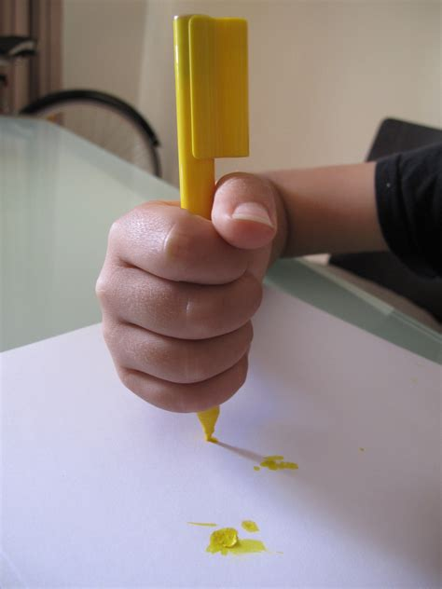 | 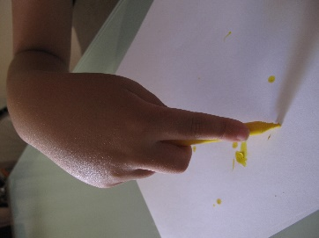  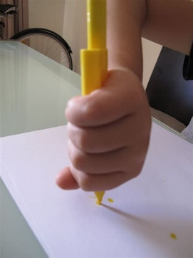 | 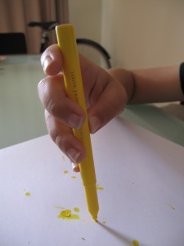 | 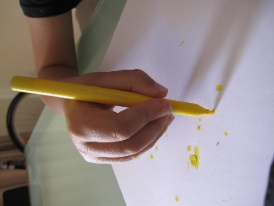 | 