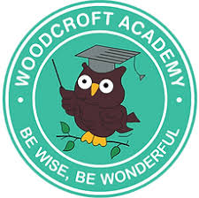
Woodcroft Academy – EYFS Curriculum Overview – 2025/26

Rising Three Provision

Our curriculum for our youngest pupils is nursery rhyme and provision based. Children access short, gradually built up carpet sessions based around a different nursery rhyme each week and then complete a short activity based on a different areas of the foundation stage framework for children aged 3-4 years each day. The delivery of this is agreed upon dependant on the number of three year olds accessing the provision and also once children have settled into the usual daily routines of school life. Foundational knowledge and executive function are prioritised within the planning of this to ensure that children are best fit with the skills required for the next stage in their school life. Please see our rising three planning document for more detailed information.
We have linked a key text to each nursery rhyme that will be shared and explored by the children in their week of focus on that nursery rhyme.
Nursery Rhyme | Twinkle Twinkle  How to catch a star by Oliver Jeffers  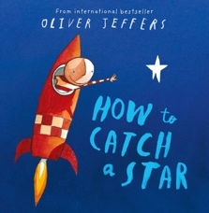 | I can sing a rainbow  How do you make a rainbow by Caroline Crowe and Cally Johnson-Isaacs  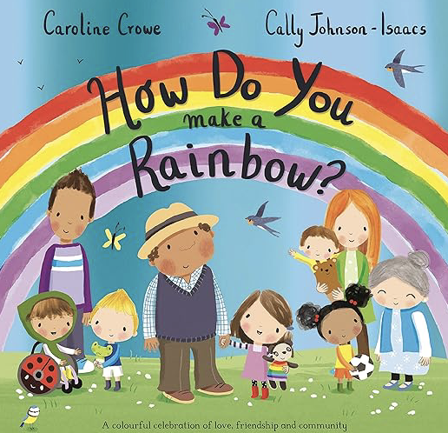 | Down in the jungle  Monkey Puzzle by Julia Donaldson  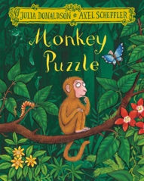 | Wiggly Woo  Superworm by Julia Donaldson  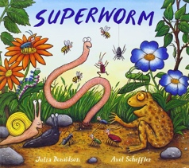 | Humpty Dumpty  King Charles by Big People, Little Dreams  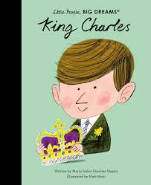 | Heads, shoulders, knees and toes  My body by Jill McDonald  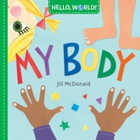
Nursery Rhyme | The grand ole Duke of York  Ron the Royal Guard by Deano Yipadee and Paul Beavis  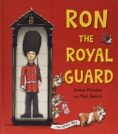 | Baa Baa Black Sheep  The lost sheep Bible story  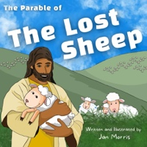 | Incy Wincy Spider  The very busy spider by Eric Carle  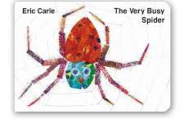 | Wind the Bobbin Up  My First Thesaurus  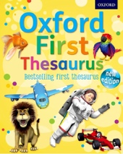 | I hear thunder  Weather non-fiction text  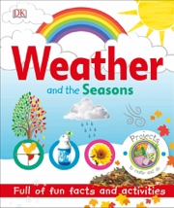 | 5 little speckled frogs  Oi Frog! By Kes Gray and Jim Field  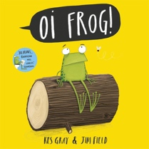
Nursery Rhyme | Miss Polly had a dolly  Zog and the Flying Doctors by Julia Donaldson  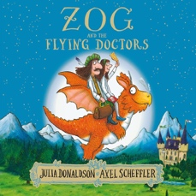 | Old Macdonald had a farm  Farmer Duck by Martin Waddell and Helen Oxenbury  