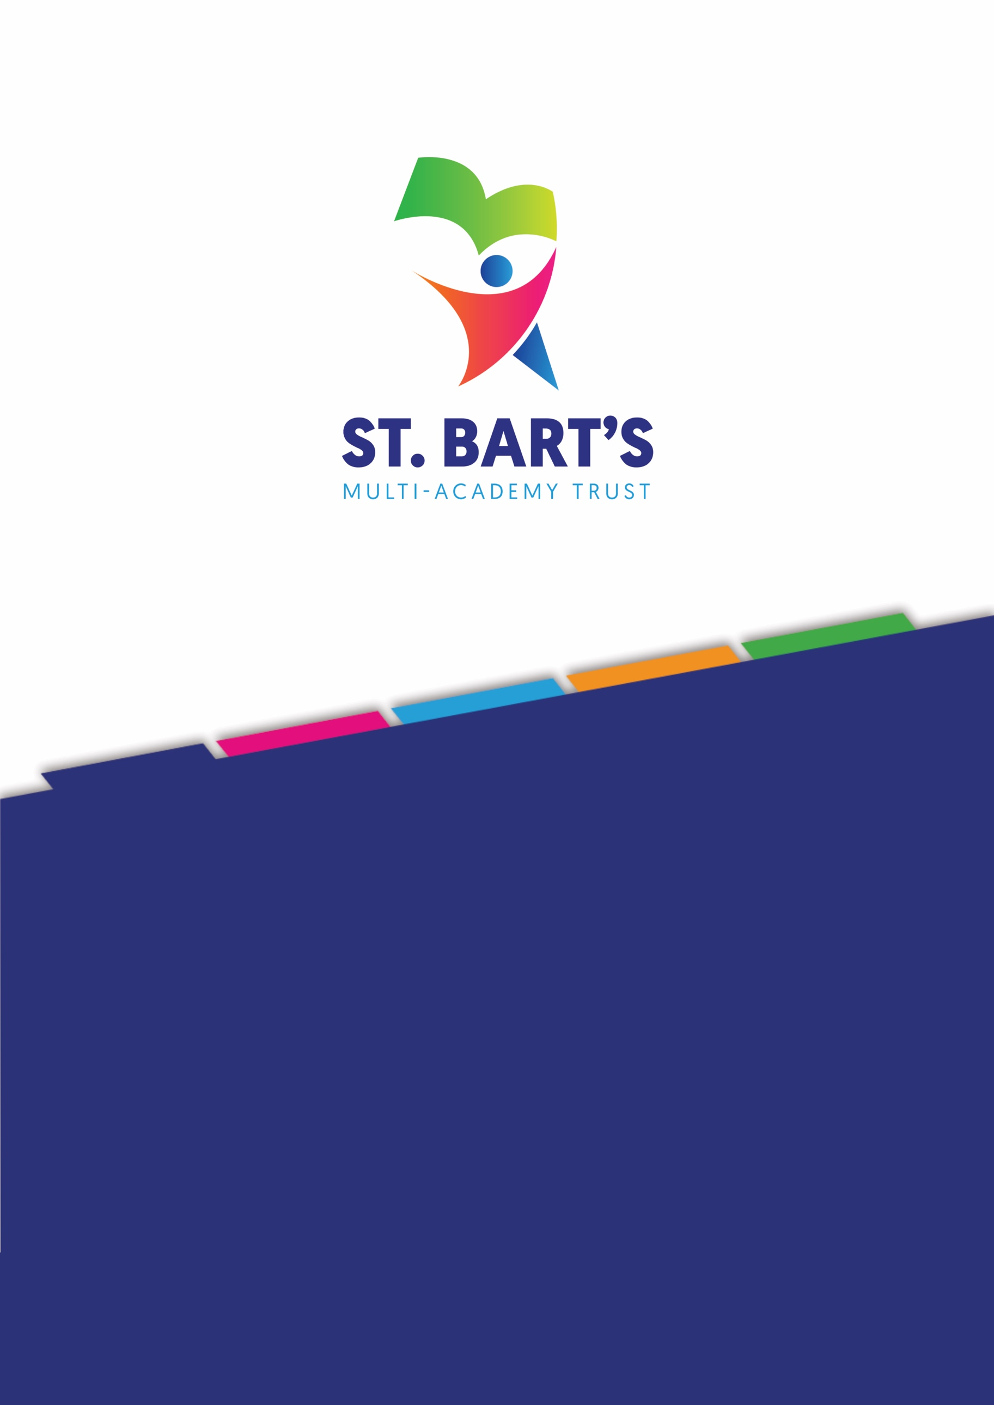

EARLY YEARS FOUNDATION STAGE (EYFS) POLICY

October 2025

Title: | Early Years Foundation Stage (EYFS) Policy
Issued: | December 2025
Next Review: | December 2027
Owner: | Linda Jones
Category: | Operational
Details

Date | Section Amended | Signature
December 2025 | New Policy | LJ

Contents

St. Bart’s Mission 4
St. Bart’s Vision and Values 4
St. Bart’s Sustainability 4
Early Years Foundation Stage (EYFS) Policy 5
Statement of Intent 5
1. Key Areas of the EYFS Framework 7
1.1. Learning and Development Requirements 7
1.2. Characteristics of Effective Learning 7
1.3. Playing and Exploring 7
1.4. Active Learning 7
1.5. Creating and Thinking Critically 7
1.6. Phonics and Reading 8
1.7. Communication and Language 8
1.8. Mathematics 9
1.9. Literacy (Writing) 9
2. Assessment Requirements 10
3. Safeguarding and Welfare Requirements 10
4. Snack/nutrition 11
5. Behaviour 11
6. Intimate Care 11
7. Sleep in the Early Years 12
8. Care Plans 12
9. Partnership with Parents 12
10. Inclusion and Equal Opportunities 13
11. Transition 13
11.1. Transition into the setting 13
11.2. Transition within the setting 13
11.3. Transition to Primary School 14
11.4. Supporting Families 14
Appendix 1 – Intimate Care Plan 15

St. Bart’s Mission
Our mission is to ADVANCE EDUCATION and to provide the best curriculum in all our academies, enabling every child to realise their full potential.

St. Bart’s Vision and Values
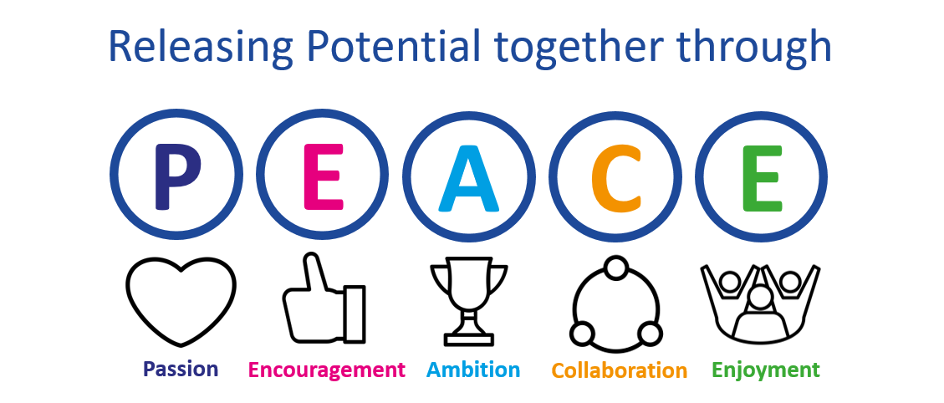
We have a Passion for releasing potential in all our children and staff through the Encouragement and development of Ambition, aspiration and excellence in all aspects of our work. Our commitment is to place children at the centre of everything we do. Working in Collaboration, we strive to provide the highest quality of educational experiences and outcomes for young people in an inclusive environment. Through the Enjoyment of learning, we live life together in all its fullness through PEACE.
We believe this vision empowers children with the skills to make a positive impact on the future of the communities they serve.
Our Trust Christian ethos is also captured by the PEACE values and all schools work in close partnership (whether C of E or community) to ensure that all children, adults and the communities they serve flourish just as Jesus encouraged us to do in John 10:10 –
“I have come that they may have life, and have it to the full.”

St. Bart’s Sustainability
We are committed to educating our pupils about environmental concerns and the importance of living sustainably. We recognise our responsibility to ensure that pupils are prepared for a world impacted by climate change through learning and practical experience.
We encourage both pupils and staff to think about the environment and how their actions will impact upon their local surroundings, as well as the global environment.
We will ensure pupils are taught about environmental sustainability, promote an eco-friendly attitude, and ensure that the Trust itself is as sustainable as it can be.

Early Years Foundation Stage (EYFS) Policy
“Every child deserves the best possible start in life and the support that enables them to fulfil their potential.
Children develop quickly in the early years and a child’s experiences between birth and the age of five have a major impact on their future life chances. A secure, safe and happy childhood is important in its own right. Good parenting and high-quality early learning together provide the foundation that children need to make the most of their abilities and talents as they grow.”
(EYFS Framework – January 2024).

Statement of Intent
At St. Bart’s Multi-Academy Trust, we are united in our belief that the Early Years Foundation Stage is a critical phase in every child’s educational journey. Our intent is to deliver exceptional early years provision that meets the strong standards set out in the 2025 Ofsted inspection framework, ensuring that every child thrives in a safe, inclusive, and enriching environment.
We aim to:
- Secure strong foundations in communication, language, literacy, and numeracy through a curriculum that is ambitious, coherent, and responsive to children’s needs.
- Promote personal development by nurturing resilience, independence, and emotional wellbeing in every child.
- Champion equity and inclusion, ensuring that all children — regardless of background, need, or starting point — make strong progress and feel a sense of belonging.
- Embed safeguarding as a culture, not a checklist, with all staff trained and confident in identifying and responding to concerns.
- Use resources efficiently and effectively, ensuring that staffing, environments, and planning are purposeful and impactful.
- Empower families as co-educators, building strong partnerships that support children’s learning and development beyond the classroom.
Across our trust, we do not view EYFS as preparation for school — we see it as the foundation of a child’s lifelong learning. Our provision is designed to meet the expected standards and exceed them wherever possible, with a clear focus on continuous improvement, reflective practice, and professional development.
We adhere to the Early years’ foundation stage statutory framework for group and school-based providers (effective: September 2025) and the four guiding principles that shape practice within Early Years settings:
- Every child is a unique child, who is constantly learning and can be resilient, capable, confident and self-assured.
- Children learn to be strong and independent through positive relationships.
- Children learn and develop well in enabling environments with teaching and support from adults, who respond to their individual interests and needs and help them to build their learning over time. Children benefit from a strong partnership between practitioners and parents and/or carers.
- Children develop and learn in different ways and at different rates.
We have designed a curriculum that is supported by the non-statutory guidance set out in Birth to 5 (2021) and Development Matters (2023). These documents support us in our statutory responsibilities within the EYFS areas of learning and development and educational programmes. Our curriculum is coherently planned, progressive and sequenced. The design ensures all children (regardless of backgrounds, circumstances, or needs) learn and develop well over time.
The following seven key features of effective practice, as set out in Development Matters, support our curriculum:
- The best for every child
- High-quality care
- The curriculum: what we want children to learn
- Pedagogy: helping children to learn
- Assessment: checking what children have learnt
- Self-regulation and executive function
- Partnership with parents
As part of our best practice we:
- Provide a balanced curriculum, based on the EYFS, across the seven areas of learning.
- Promote equality of opportunity and anti-discriminatory practice.
- Provide early intervention for those who need additional support.
- Work in partnership with parents and where needed outside agencies.
- Plan challenging learning experiences for all our children, based on the individual needs of the child.
- Provide opportunities for our children to engage in adult led learning and self-initiated learning.
- Provide a secure and safe learning environment indoors and outdoors.
- Plan an exciting and challenging curriculum based on our observations of children’s needs, interests and stages of development across the seven areas of learning.
- Deliver a broad and balanced education where learning is sequential so that the children learn and remember one thing before they move on to the next.
- Key Areas of the EYFS Framework

Learning and Development Requirements
We plan and implement an exciting and challenging curriculum based on our observation of children's needs, interests, and stages of development across the seven areas of learning to enable children to achieve the early learning goals.
Our curriculum is based on the seven areas of learning:
- Prime Areas: Communication and Language, Physical Development, Personal, Social and Emotional Development.
- Specific Areas: Literacy, Mathematics, Understanding the World, Expressive Arts and Design.
We use a play-based approach, guided by children’s interests and developmental needs.

Characteristics of Effective Learning
The characteristics of effective learning run through and underpin all seven areas of learning and development, representing processes rather than outcomes. Learners demonstrate their admirable attitudes and positive behaviours through these key characteristics.

Playing and Exploring
Children will have purposeful and meaningful opportunities to investigate, experience and explore. Through engagement in play, children explore and enquire, developing learning experiences which help them to make sense of the world. They practise and build on ideas, think creatively alongside other children as well as independently. They communicate, investigate and solve problems building relationships and collaborative skills.

Active Learning
Children will have time and space to persevere when encountering challenges. Children take pleasure in celebrating their own and others achievements and successes. Active learning occurs when children are motivated and interested. Children develop independence, control and ownership of their learning. As children develop their confidence, they learn to make decisions.

Creating and Thinking Critically
Children are actively encouraged and supported to develop their own ideas, make connections between their learning and develop independent strategies when completing challenges. Children are given the opportunity to be creative through all areas of learning. Adults support and extend children's thinking and help them to make connections through modelling, offering encouragement, clarifying ideas and asking open ended questions. Learners access resources and move independently around the learning environment; enabling them to extend their learning.

Phonics and Reading
We believe that all our children can become fluent readers and writers. This is why we teach reading through the DFE validated Programme Bug Club, which is a systematic and synthetic phonics programme. We start teaching phonics in Nursery and follow the Bug Club progressive programme, which ensures children build on their growing knowledge of the alphabetic code, mastering phonics to read and spell as they move through school.
We believe that reading is at the heart of a rich early years’ experience and vital to children’s long-term learning and life chances. Our reading provision ensures every child develops a love of stories, strong language skills, and early decoding abilities, laying the foundations for fluent reading. We immerse children in spoken language and stories from the start. Through songs, rhymes, storytelling, and rich conversation, we develop vocabulary, comprehension, and a love of language. Children are taught to read using our systematic synthetic phonics programme, Bug Club, ensuring they gain the skills to decode words confidently and accurately. Teaching is consistent, cumulative, and regularly reviewed. We foster a genuine love of reading through high-quality picture books, diverse stories, poetry, and non-fiction. Children have daily opportunities to listen to and engage with books read aloud by enthusiastic adults. Reading and books are integrated throughout all areas of provision. Children encounter texts in role-play, topic work, and through story-based learning. Teaching is responsive. We identify and support children who may need additional help with phonics, comprehension, or language development, ensuring no child is left behind. We encourage all children to see themselves as readers. Through praise, choice, and meaningful experiences, we build children’s confidence, curiosity, and motivation to read. We actively involve parents and carers in supporting reading at home. We share books, strategies, and updates so that reading becomes a valued, shared experience beyond the setting.

Communication and Language
We recognise that strong communication and language skills are foundational to all areas of learning. Guided by recent research including Best Start in Life 2024 and the Education Endowment Foundation—we commit to providing rich, responsive, and inclusive language learning environments.
Our curriculum clearly sets out what children should learn in vocabulary, listening, understanding, and speaking. We include both planned activities and everyday opportunities to support language throughout the day. Children learn in a language-rich environment filled with stories, rhymes, songs, poems, and non-fiction. New words are taught and used in different ways—through both play and adult-led sessions. We pay close attention to children who may need extra help—such as those with less language experience, those with SEND, or those learning English as an additional language. We regularly check children’s progress and give support when needed. Play is at the heart of our approach. Adults join children in play with clear learning goals, helping them practise language in fun, meaningful ways. Short adult-led sessions are used when needed—for example, to teach new words or sentence structures. We teach children to listen carefully, follow instructions, and understand spoken language through stories, games, and everyday routines. We also help children express themselves confidently, to share ideas, ask questions, and solve problems through talk. We welcome mistakes as part of learning. We work closely with parents and carers to support language at home. We celebrate and include children’s home languages and cultural backgrounds in our setting.

Mathematics
We recognise that early mathematics is a vital part of children's cognitive development and forms the foundation for lifelong numeracy and problem-solving skills. Our approach to mathematics in the Early Years is informed by the EYFS framework and guided by the Ofsted’s Research - Strong foundations in the first years of school.
We prioritise developing a deep understanding of numbers to 10, supporting children's ability to subitise, count, compare, compose and decompose numbers. Children explore mathematical ideas through purposeful play, exploration, and everyday routines. Adults model mathematical language and thinking, encouraging talk and reasoning. We provide rich opportunities for exploring shape, space, measures, patterns, and visualisation—supporting broader mathematical thinking beyond number. Our maths provision is carefully sequenced and builds cumulatively, ensuring children revisit and deepen core concepts over time, preparing them for KS1. We ensure all children, including those with SEND or EAL, access high-quality maths learning. Teaching is responsive, building on children's interests, needs, and prior understanding. We nurture children's confidence, curiosity, and enjoyment of maths. Mistakes are valued as part of learning, and all children are encouraged to see themselves as capable mathematicians. Families are supported to understand and reinforce early maths at home through shared strategies, games, and everyday activities.
To support us with this we use Pearson’s Power Maths scheme alongside the NCETM’s Mastering Number programme.

Literacy (Writing)
We believe writing is a crucial skill that enables children to express themselves, build literacy, and communicate meaning. In line with the 2025 DfE Writing Framework and EYFS guidance, our writing provision is based on the following principles:
Writing starts with strong foundations in talk, phonics, and early transcription skills. We support oral composition alongside early handwriting and spelling through modelling, dictation, and shared writing. We encourage writing through purposeful play, using a range of tools and materials indoors and outdoors. Children are supported to see mark-making as meaningful and enjoyable. We plan for progression in handwriting, spelling, and sentence work, preparing children for a smooth transition to Key Stage 1. Adults model writing, provide scaffolding, and use strategies such as guided writing and dictation to support children in moving towards independent writing. Writing is embedded across all areas of learning. Children are given real reasons to write, connecting their writing to stories, play, and topics that matter to them. We use ongoing assessment to tailor support. Children receive timely help when needed, and we ensure all aspects of writing (transcription and composition) are developed. Every child is supported to become a confident writer. We celebrate diversity, respect different starting points, and build writing experiences around children’s identities and languages. We work with families to support writing at home and school. We value writing that happens beyond the setting and encourage home-school connections.
- Assessment Requirements
Assessment in the EYFS is a continuous and integral process that underpins children’s development. Skilled practitioners consistently notice, identify, and interpret how children engage in play and learning. These insights inform the planning of tailored learning experiences that reflect each child’s individual needs and interests. The statutory assessment requirements include:
- The Early Years Foundation Stage Profile (EYFSP): This is the statutory assessment completed at the end of the Reception year, which summarises a child's progress against the Early Learning Goals (ELGs) in all seven areas of learning.
- Development Matters: This non-statutory guidance document helps practitioners track children’s progress and plan effectively. It outlines expectations for children’s development and provides guidance on what children should be able to do at various stages.
Within the first 6 weeks that a child starts reception, staff will administer the Reception Baseline Assessment (RBA). At the end of the EYFS, staff complete the EYFS profile for each child. Children are assessed against the 17 early learning goals, indicating whether they are:
- Meeting expected levels of development or not yet reaching expected levels (emerging)

- Safeguarding and Welfare Requirements
All reasonable measures are taken to ensure the safety of all children in the EYFS. Children learn best when they are healthy, safe and secure, when their individual needs are met, and when they have positive relationships with the adults caring for them. We follow the safeguarding and welfare requirements detailed in the ‘Keeping Children Safe in Education 2025’ statutory guidance and adhere to the Academy’s Child Protection and Safeguarding Policy.
Our pupil’s welfare is our paramount concern, and we will always act in the best interests of the child. We recognise the importance of providing a school environment where pupils feel safe and respected. We encourage pupils to talk openly and to feel confident that they will be listened to. We recognise that all adults within the school have a full and active part to play in protecting our pupils from harm and as such they will always exercise ‘professional curiosity.’
We will work closely with parents and carers to ensure their understanding of the school’s responsibilities to safeguarding and promote the welfare of their children, which may include the need to make referrals to other agencies in some situations. We liaise with other professionals to ensure our children have the best support in their learning and development.
To ensure we are fully compliant with statutory guidance we:
- Follow clear policies on child protection, health and safety, and manage behaviour effectively.
- Ensure staff have appropriate qualifications and training, including paediatric first aid.
- Adhere to ratios of staff to children according to age group:
  - 1:13 for children aged 3+ with a qualified teacher.
  - 1:8 for children aged 3+ without a teacher.
  - 1:4 for children aged 2.
  - 1:3 for children under 2.

- Snack/nutrition
During snack times, a paediatric first aid-trained staff member is present, and children are seated safely with minimal distractions to reduce choking risks. We gather and regularly update information on each child’s dietary needs, allergies, and intolerances and ensure all staff are informed and vigilant. Allergy action plans are developed in consultation with parents and healthcare professionals, and food preparation follows strict hygiene and safety protocols. These measures ensure snack time supports children's health, development, and well-being in a secure and inclusive environment. Children are closely supervised during mealtimes to ensure their safety, with a paediatric first aid-trained staff member present always to respond promptly to any incidents such as choking or allergic reactions.

- Behaviour
We aim to create a positive, respectful, and inclusive environment where children feel safe, valued, and supported. It recognises that behaviour is developmental and best guided through nurturing relationships and meeting children’s emotional and social needs. Staff model respectful behaviour and set clear expectations for kindness, cooperation, and engagement in routines. Positive reinforcement, such as praise and restorative approaches, are used to encourage appropriate behaviour, while punitive measures are avoided. When challenges arise, staff use age-appropriate guidance and work closely with parents to support consistent responses. Bullying or harm is taken seriously and is addressed in line with safeguarding procedures. All staff share responsibility for promoting positive behaviour.
Please also refer to the school’s Safeguarding, SEND, Behaviour and Health and Safety policies for further information.

- Intimate Care
Intimate care within the EYFS setting is carried out in accordance with the statutory framework and safeguarding guidance to ensure children's dignity, safety, and well-being. It includes tasks such as nappy changing, toileting assistance, and support with dressing or washing, and is always conducted respectfully and sensitively by trained staff. Procedures are designed to minimise risk and uphold the child’s privacy, with parental consent obtained and individual care plans developed where necessary. Staff follow clear protocols to protect both themselves and the children, including recording care provided and reporting any concerns to the designated safeguarding lead. The policy ensures that intimate care is child-centred, inclusive, and aligned with the Equality Act 2010 promoting a safe and nurturing environment for all children.

- Sleep in the Early Years
Staff must ensure the safety of children when sleeping in setting as set out in
September 2025 - Statutory framework for the early years foundation stage (publishing.service.gov.uk)
September 2025 - EYFS statutory framework for group and school based providers (publishing.service.gov.uk)

- Care Plans
Where a pupil has an identified need (E.g. wearing nappies or pull-ups regularly, or has continence difficulties which are more frequent than the odd ‘accident’, staff will work with parents/carers (and health visitors/school nurse/internal family support officer, if appropriate) to set out a care plan to ensure that the child can attend daily. The written care plan (Appendix 1) will include:
- Who will change the child on a day-to-day basis?
- Contact details for the person coming in to change the child (if appropriate)
- Where changing will take place
- Clarification that the parent/carer is responsible for the provision of the resources and equipment.
See Intimate Care Policy.

- Partnership with Parents
Partnerships with parents are a cornerstone of effective practice in the Early Years Foundation Stage (EYFS), as emphasised in the statutory framework. Building strong, respectful relationships with families supports children's learning, development, and wellbeing. Practitioners work collaboratively with parents, valuing their insights and contributions, and ensuring they are actively involved in their child’s early education. Each year, every child is assigned a key person (the class teacher) who helps to ensure that their learning and care is tailored to meet their individual needs. The key person supports parents and/or carers in guiding their child’s development at home as we recognise that the home learning environment can have a significant impact on each child’s learning. Through this, we encourage all our parents to talk, play and read with their children regularly. Regular communication—through daily updates, meetings, and shared observations via their individual learning journey and our shared class group on Showbie helps create a consistent approach between home and school. By fostering trust and openness, EYFS providers empower parents to engage meaningfully in their child’s journey, promoting positive outcomes and a shared sense of responsibility.
The Statutory EYFS profile at the end of Reception helps to provide parents and/or carers with a well-rounded picture of their child’s knowledge, understanding and abilities when leaving the EYFS as well as their readiness for year one.

- Inclusion and Equal Opportunities
We are committed to creating an environment where every child is valued, respected, and supported to reach their full potential. We believe that equality and inclusion are fundamental to providing high-quality early education.
We actively promote inclusive practice by recognising and celebrating the diverse backgrounds, abilities, cultures, and languages of all children and their families. Our curriculum and learning environment are designed to be accessible and responsive to individual needs, ensuring that no child is disadvantaged or excluded.
Practitioners are trained to identify and address barriers to learning, providing timely interventions and adaptations to support children with SEND, EAL, and other additional needs. We work closely with families, specialist agencies, and the wider community to foster a culture of respect, empathy, and belonging.
We are dedicated to promoting positive attitudes, challenging stereotypes, and encouraging children to appreciate diversity, ensuring that everyone feels safe, included, and valued.

- Transition
Transition is a vital part of children’s early education journey. We aim to make transitions into our setting and onwards to school as smooth and positive as possible for children and their families.

Transition into the setting
We support children starting with us by:
- Welcoming families during open mornings and ‘meet the teacher’ events.
- Sharing information about children’s needs and interests through visiting them at home and/or their current setting if they attend one and opening communication through a new-to-school Showbie group and email system.
- Gradually introducing children to the environment via our open mornings, stay and play sessions and transition/taster days as well as information videos for parents and children to watch together. We will also begin with a phased induction to build up time gradually if we feel this would be necessary for your child.

Transition within the setting
To support transitions between rooms or key stages, we:
- Facilitate visits and introductions to new key workers or classrooms through transition/taster days and story times with our new teachers and wider school staff.
- Share learning records and observations to maintain continuity in provision.
- Encourage conversations with children about upcoming changes to prepare them emotionally.

Transition to Primary School
Preparing children for the move to school involves:
- Liaising closely with receiving schools via in person, video or written communication.
- Supporting children to become familiar with their new school environment through social stories, supported visits and sharing of photographs/videos.
- Engaging parents in transition by offering ‘meet the teacher’ events and sharing a one-page profile about your child’s teacher on Showbie.

Supporting Families
We recognise that transition can be an anxious time for families and provide:
- Clear communication channels including specific new-to-school Showbie groups, email systems and our friendly office team are always on the end of the phone to help with any questions.
- Opportunities for families to discuss concerns and ask questions at parents evenings, home visits, and daily via in person drop off and collection times and over email message.

Appendix 1 – Intimate Care Plan
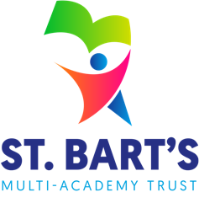
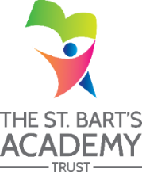
ST. BART’S MULTI-ACADEMY TRUST
Intimate Care Plan

Academy:

PARENTS/CARERS
Name of child
Type of intimate care needed
How often care will be given
What training staff will be given
Where care will take place
What resources and equipment will be used, and who will provide them
How procedures will differ if taking place on a trip or outing
Name of senior member of staff responsible for ensuring care is carried out according to the intimate care plan
Name of parent or carer
Relationship to child
Signature of parent or carer
Date

CHILD
How many members of staff would you like to help?
Do you mind having a chat when you are being changed or washed?
Signature of child
Date

